ASSIGNMENT 1

Assignment topic: Design, Implement and Validate the Fare Logic of a City Metro Smart-Card System

TASK 1 – Understand the Problem and Identify the Objects (4 Marks)
1. Objects and their data and behaviour
Object | Data | Behaviour
SmartCard | Card ID, balance | Check balance, deduct fare
Passenger | Name, passenger type | Get concession
Journey | Source, destination, fare | Calculate fare
Zone | Zone name, fare | Identify travel zone
FareTable | Base fares | Provide fare details

2. Procedural and OOP approach
- Procedural programming uses separate variables and functions.
- OOP combines data and functions inside classes.
- OOP makes the program easier to maintain, reuse and modify.
3. Basic OOP principles
- Encapsulation: Keeps card balance private.
- Abstraction: Shows only necessary operations to the user.
- Inheritance: Student and SeniorCitizen can inherit from Passenger.
- Polymorphism: Different passengers can have different concession calculations.
4. Rules of a correct journey
- Fare must not be negative.
- Balance must remain at least Rs.50.
- Peak surcharge applies only from 8–10 AM and 5–8 PM.
- Invalid zones must be rejected.
- Money must be calculated accurately using paise.

Alternative concept and complexity analysis
In procedural programming, global variables and separate functions are used instead of classes. Both approaches take O(1) time per journey and O(1) memory per card. However, OOP is easier to maintain because changes can be made inside the relevant class without affecting the entire program.

C++ Program
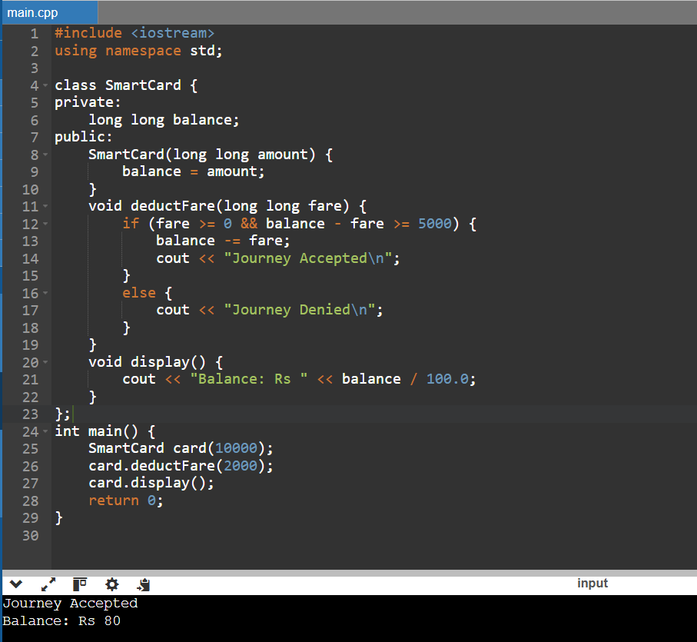

TASK 2 – Use Tokens, Keywords, Identifiers and Constants Correctly (3 Marks)
1. Five types of tokens
Token | Example
Keywords | int, class, return
Identifiers | balance, fare
Constants | 1000, 2000
Operators | + , - , ==
Punctuators | ; , { } , ( )

2. Types of constants
- #define: Defines a macro constant.
- const: Creates a read-only variable.
- constexpr: Creates a compile-time constant when its initializer permits it.
constexpr is preferred because it provides type checking and compile-time evaluation.
3. enum and enum class
enum defines named values, whereas enum class provides scoped values and avoids accidental conversions.

4. Naming conventions
Identifiers should begin with a letter or underscore. Keywords cannot be used as identifiers. Meaningful names such as totalFare and balance should be used.
Alternative concept and complexity analysis
Using #define instead of constexpr removes type checking and scope protection. Both approaches have O(1) execution time. A constexpr value usually requires no runtime storage when used as a compile-time constant.

C++ Program

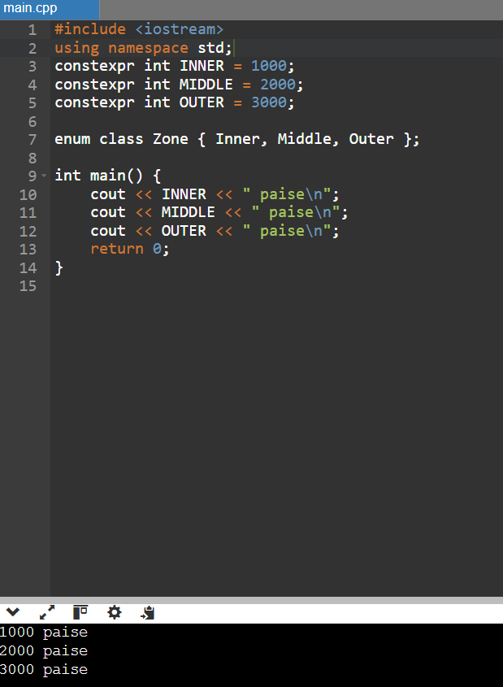

TASK 3 – Choose Data Types and Check Type Compatibility (4 Marks)

1. Suitable data types

Value | Data type | Purpose
Peak hour | bool | True or false
Zone | char | Zone identification
Hour | int | Stores hour
Balance | long long | Stores paise
Fare | long long | Stores fare
Journey count | long long | Large journey count
Percentage | double | Decimal calculation

2. Why integer paise is preferred

Money should be stored in integer paise instead of double rupees because floating-point values may cause rounding errors. Example: Rs.10.50 = 1050 paise.

3. Type compatibility

- int + double produces double.
- int converted to bool becomes true if non-zero.
- char is promoted to int during arithmetic.

4. Size and range (typical modern system)

Data type | Typical size
bool | 1 byte
char | 1 byte
int | 4 bytes
long long | 8 bytes
float | 4 bytes
double | 8 bytes

5. Network collection calculation (assuming Rs.36 = 3600 paise per journey)

Journeys | Total collection
20,000 | Rs.7,20,000
5,00,000 | Rs.1,80,00,000
30,00,000 | Rs.10,80,00,000

The network total exceeds the maximum value of a signed 32-bit int when stored in paise. Therefore, long long is preferred.
Alternative concept and complexity analysis
If double rupees are used, floating-point rounding errors may occur when many fares are added. Integer paise and double addition both take O(1) time and typically use 8 bytes. Integer paise gives exact monetary calculations within the supported range.

C++ Program

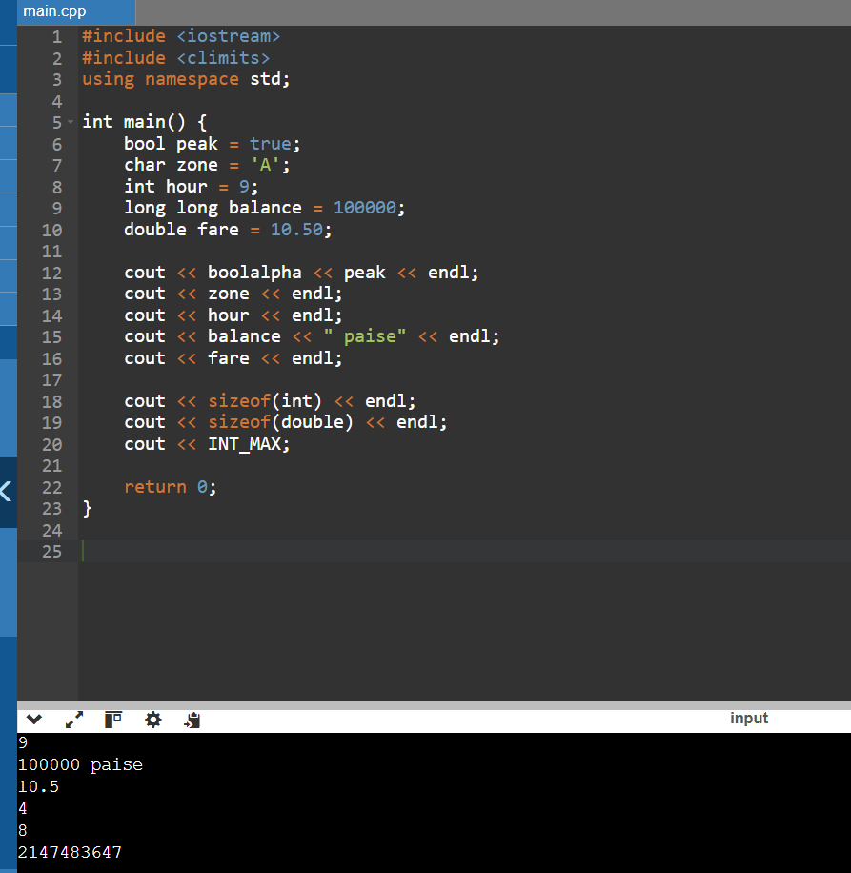

TASK 4 – Control Implicit Conversions (4 Marks)

1. Integer division
int a = 7, b = 2;
double c = a / b; // Result: 3

2. Integer to double conversion
double d = static_cast<double>(a) / b; // Result: 3.5

3. Signed and unsigned comparison
When a negative signed integer is compared with an unsigned integer, the signed value may be converted to unsigned. This can produce unexpected results.
4. Narrowing conversion
int x{3.7}; // Compilation error: narrowing conversion

5. static_cast
double x = static_cast<double>(7) / 2; // Result: 3.5

Predict the output
3 3.5
C 68
1 true
s >= u

Explanation: 7/2 gives 3 because of integer division; explicit conversion gives 3.5. 'A'+2 produces C, while ch+1 promotes the character to integer 68. Integer 5 converts to Boolean true. Signed -1 is converted to unsigned during comparison, so s >= u is printed.

Alternative concept and complexity analysis
Explicit conversions reduce unexpected implicit conversions. Brace initialization catches narrowing errors during compilation. Runtime time and memory generally remain O(1) for these operations.

TASK 5 – Write Correct Expressions with the Right Precedence (4 Marks)
1. Peak-hour expression
(hour >= 8 && hour < 10) || (hour >= 17 && hour < 20)

2. Surcharge calculation
fare += fare * 20 / 100;

3. Concession calculation
fare -= fare * 10 / 100;

4. Operator precedence
- *, /, % have higher precedence than +, -.
- Relational operators are evaluated before logical AND.
- && has higher precedence than ||.
- Conditional operator ?: selects one of two values.
- Compound assignment += adds and assigns the result.
5. Increment operators
- x++ uses the old value and then increments.
- ++x increments first and then uses the new value.
- i = i++ should be avoided because it is an unsafe and confusing way to modify the same variable.
6. Negative division and modulus
-10 / 3 = -3\n-10 % 3 = -1

Predict the output
11 16
9 6 4
6 4
3 1 -3 -1
18

Explanation: Multiplication is performed before addition. Post-increment and pre-increment are used in the second line. Conditional and modulus operators are used in the third line. Integer division and modulus are applied in the fourth line. The loop adds 0, 3, 6 and 9.

Alternative concept and complexity analysis
A lookup table bool peak[24] can store whether each hour is peak or off-peak. Both methods take O(1) time. The lookup table requires approximately 24 bytes and avoids repeated logical comparisons.

TASK 6 – Design the Control Structures (4 Marks)
1. Control structures
- if-else: Checks balance and fare conditions.
- switch: Selects fare according to the zone.
- Conditional operator: Checks peak or off-peak status.
- for: Processes a fixed number of journeys.
- Range-based for: Processes elements in an array.
- while: Repeats input validation.
- break: Exits a switch or loop.
- continue: Skips an invalid journey.
If no switch case matches, the default case executes, if provided. Otherwise, the switch is skipped.
2. Pseudocode
START
READ zone and peak status
IF zone is invalid
PRINT Invalid Zone
ELSE
SELECT base fare using zone
IF peak is true
ADD 20% surcharge
ENDIF
IF balance - fare >= 5000
DEDUCT fare
PRINT Journey Accepted
ELSE
PRINT Journey Denied
ENDIF
ENDIF
STOP

3. Completed C++ program
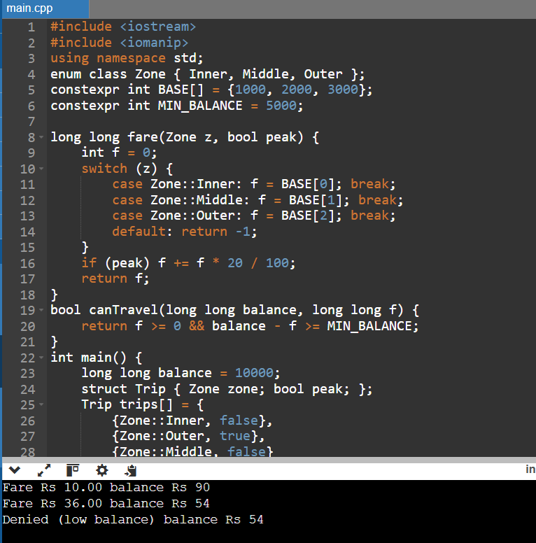

Alternative concept and complexity analysis
An array-based fare table can replace the switch statement. Both array lookup and switch selection take O(1) time. An array uses O(1) additional space for the fixed fare table. Adding a fourth zone requires extending the array and zone definition.

TASK 7 – From Procedural to Object-Oriented (4 Marks)

1. Procedural approach
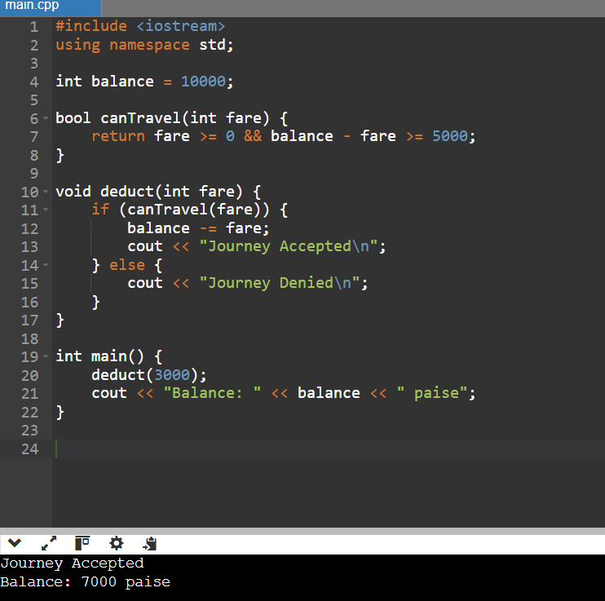

2. Object-oriented approach

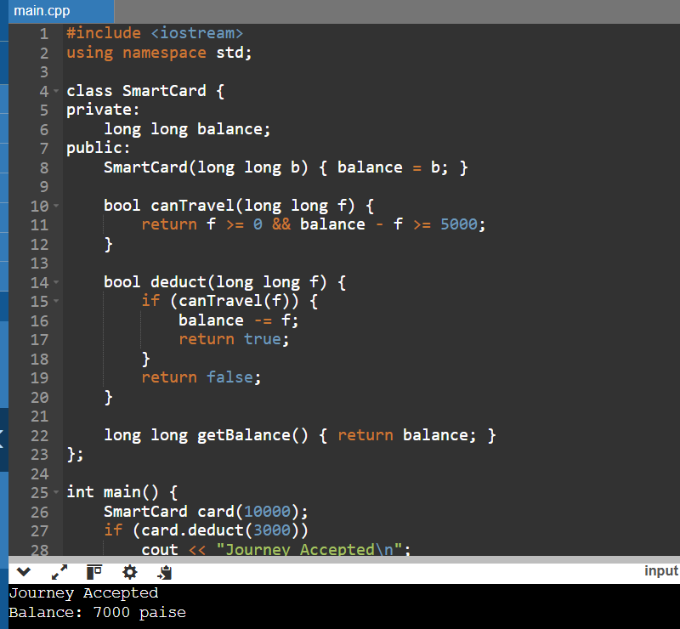

3. Comparison
- Procedural: Data and functions are separate.
- OOP: Data and functions are combined.
- Private balance prevents direct modification.
- OOP makes changing the minimum balance easier because it can be updated in one place.
Alternative concept and complexity analysis
If balance were public, any part of the program could modify it and violate the minimum balance rule. Both approaches have O(1) time and O(1) memory per card. Private data provides better protection.

TASK 8 – Read and Print Data Safely (4 Marks)
1. Safe input
cin reads values from the user. cin.fail() checks whether input is invalid.
2. Error handling
- cin.clear() clears the error state.
- cin.ignore() removes invalid input from the buffer.
- numeric_limits helps discard the remaining input.
3. Formatting
- setw(): Sets field width.
- setfill(): Fills empty spaces.
- fixed: Displays fixed decimal notation.
- setprecision(): Sets decimal places.

4. C++ program
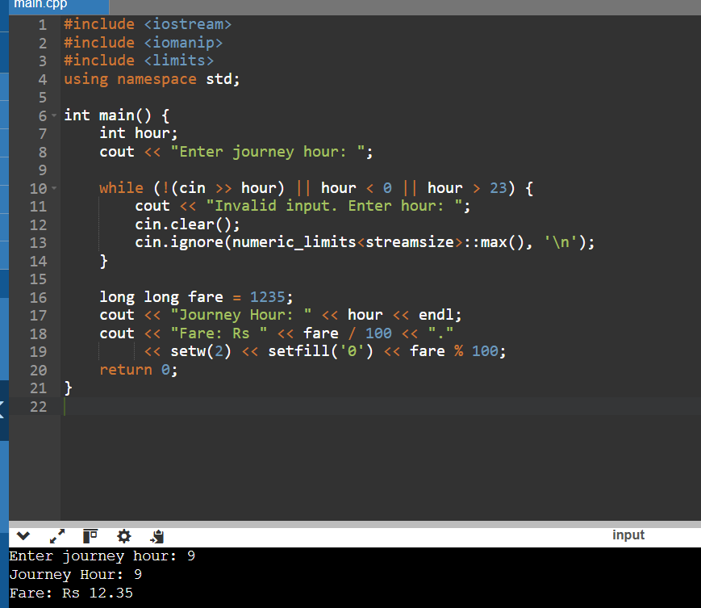

Alternative concept and complexity analysis
Using getline() and stoi() inside try-catch can handle invalid input. Both approaches take O(L) time for an input line of length L. getline() requires a buffer to store the input line, whereas cin reads formatted values directly.

TASK 9 – Implement and Test the Fare Logic (4 Marks)

1. Fare calculation
Zone | Off-peak | Peak
Inner | Rs.10 | Rs.12
Middle | Rs.20 | Rs.24
Outer | Rs.30 | Rs.36

2. Peak-hour testing
Time | Result
8:00 AM | Peak
10:00 AM | Off-peak
5:00 PM | Peak
8:00 PM | Off-peak

3. Five journey calculation (starting balance Rs.200)
Journey | Fare
Inner off-peak | Rs.10
Middle peak | Rs.24
Outer off-peak | Rs.30
Inner peak | Rs.12
Middle off-peak | Rs.20
Total | Rs.96

Remaining balance = 200 − 96 = Rs.104.
4. Test cases
Test | Expected result
Inner off-peak | Rs.10
Middle peak | Rs.24
Outer peak | Rs.36
8 AM | Peak
10 AM | Off-peak
5 PM | Peak
8 PM | Off-peak
Unknown zone | Invalid
Negative recharge | Rejected
Letters for hour | Invalid input

Alternative concept and complexity analysis
A test-case table can store inputs and expected outputs. A loop checks each test. For t test cases, time complexity is O(t), and space complexity is O(t). New boundary tests can be added easily.

TASK 10 – Compare Expectations with Execution (4 Marks)

1. Calculation (assuming fare per journey = 3600 paise = Rs.36)

Journeys | Total in paise | Total in rupees
20,000 | 72,000,000 | Rs.7,20,000
5,00,000 | 1,800,000,000 | Rs.1,80,00,000
30,00,000 | 10,800,000,000 | Rs.10,80,00,000

2. Integer overflow
- int can store values up to 2,147,483,647 on a typical signed 32-bit system.
- The 3,000,000 journey total exceeds this limit when stored in paise.
- Therefore, long long should be used.

3. Double and integer comparison
Both methods give the same expected monetary totals in this example because Rs.36 is an exact whole number of paise. However, double calculations may produce rounding errors for some decimal fares.
4. Compiler warnings
Using -Wall -Wextra helps identify unused variables, suspicious conversions and other possible programming mistakes. No warning should be assumed unless it actually appears during compilation.
Alternative concept and complexity analysis
int may overflow for the network total. long long safely stores the calculated total. double supports decimal values but may introduce rounding errors. All take O(1) time per addition; typically int uses 4 bytes and long long and double use 8 bytes.

C++ Program
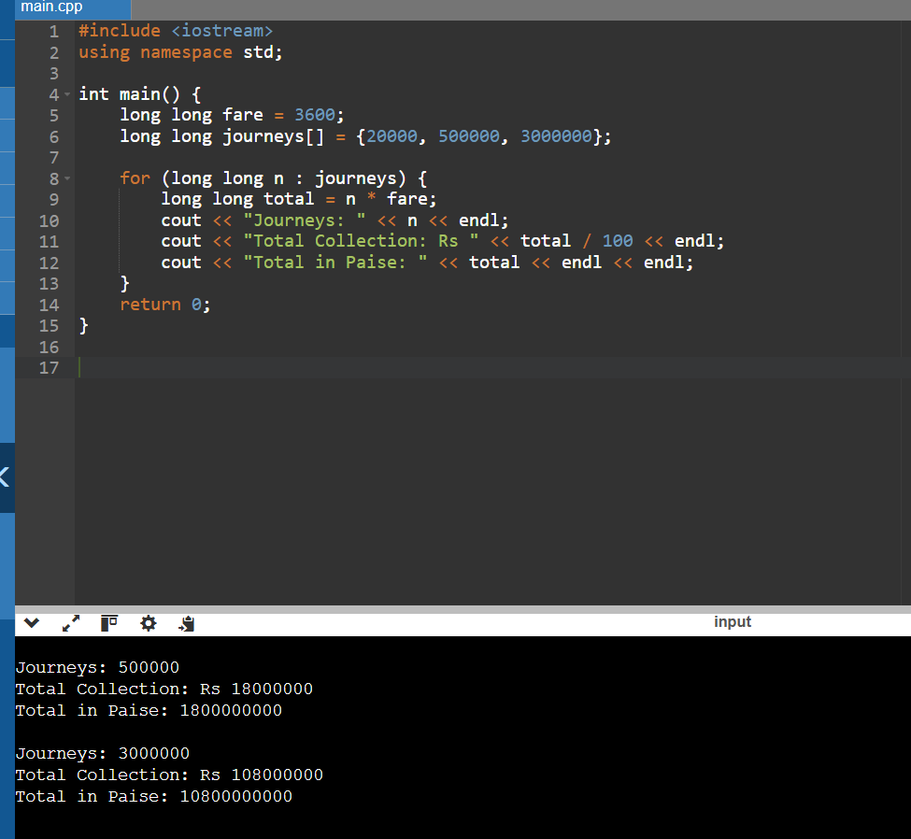

TASK 11 – Recommend and Defend the Final Design (4 Marks)

1. Recommended data types
- long long for balance and fare.
- constexpr for fixed fare values.
- enum class for zones.
- bool for peak-hour status.
- SmartCard class for card management.

2. Fare revision
Fare values should be stored in one central fare table. If the fare changes, only the table needs to be updated.

3. Limitations
- The original design supports only three zones.
- It needs modification for new discounts and monthly passes.
- It does not include database connectivity or online recharge.

4. Whole network suitability
The design uses O(1) time for each fare calculation and O(1) space per card. long long supports large collection values. Therefore, it is suitable for the whole network with proper input validation and scalable storage.

Alternative concept and complexity analysis

Instead of compiling fares into the program, they can be read from a configuration file when the system starts. Reading z fares takes O(z) time and O(z) storage. This avoids recompiling the program for every fare revision, but requires file validation.

C++ Program
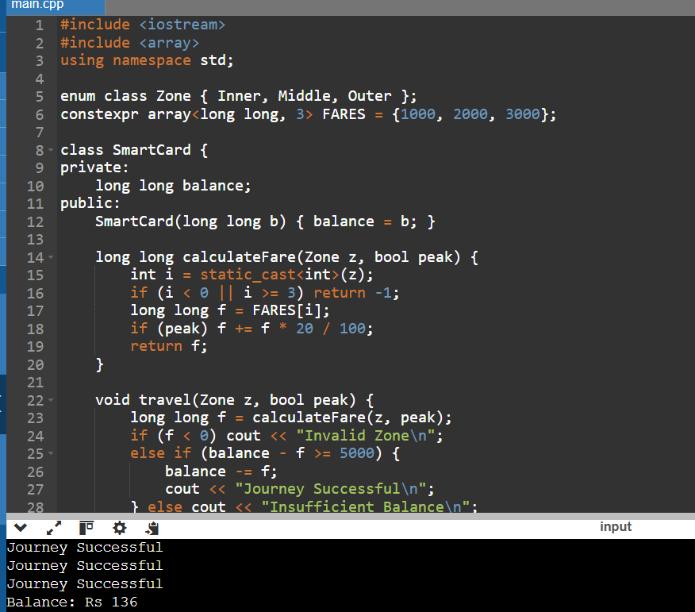

TASK 12 – Re-evaluate and Adapt the Design (8 Marks)

Changed requirement: Add Airport zone (Rs.60), a 10% weekend discount that does not combine with peak surcharge, and a monthly pass for two chosen zones.
A. Impact Analysis (2 Marks)
- Add Airport to the Zone enum.
- Increase the fare table from 3 to 4 values.
- Set Airport fare to Rs.60.
- Add a 10% weekend discount.
- Create a MonthlyPass class.
- Ensure weekend discount and peak surcharge are not combined.

B. Evaluation of Original Design (2 Marks)
The original switch-based design supports three zones. It can be modified to support Airport, but every new zone requires another case. The SmartCard class can handle balance deduction, but it needs additional logic to support monthly passes.
Worked examples
- Airport normal fare = Rs.60.
- Airport weekend fare = Rs.60 − 10% = Rs.54.
- Airport peak fare = Rs.60 + 20% = Rs.72.
- Weekend and peak together = Rs.54 because discounts do not combine.
Therefore, modification is better than retaining the original design unchanged.
C. Adaptation or Redesign (2 Marks)
- An array for four zone fares.
- A separate weekend discount condition.
- A MonthlyPass class for two selected zones.
- A SmartCard class for balance management.

C++ Program

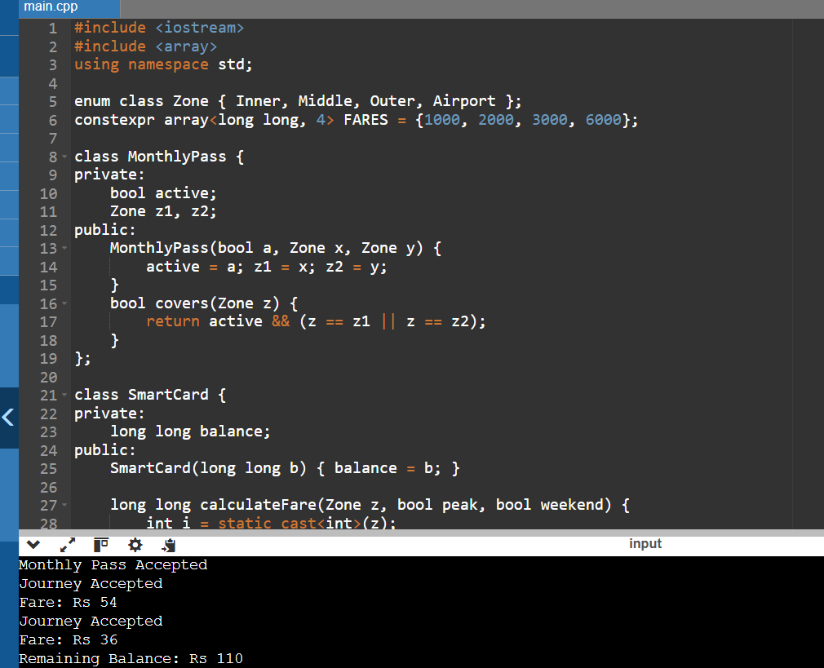

D. Evidence-Based Defence (2 Marks)
Test | Expected result
Inner with monthly pass | Pass accepted
Airport weekend | Rs.54
Outer peak | Rs.36
Airport normal | Rs.60
Airport peak | Rs.72
Invalid zone | Rejected

The modified design is better because it supports all new requirements. The fare table makes adding new zones easier, and the MonthlyPass class avoids fare deduction for covered zones.
Final decision: Modify the original design rather than completely redesigning it. The modified OOP design is reusable, maintainable and suitable for future fare changes.

